Go to

<https://developers.google.com/workspace/guides/create-project#google-cloud-console>

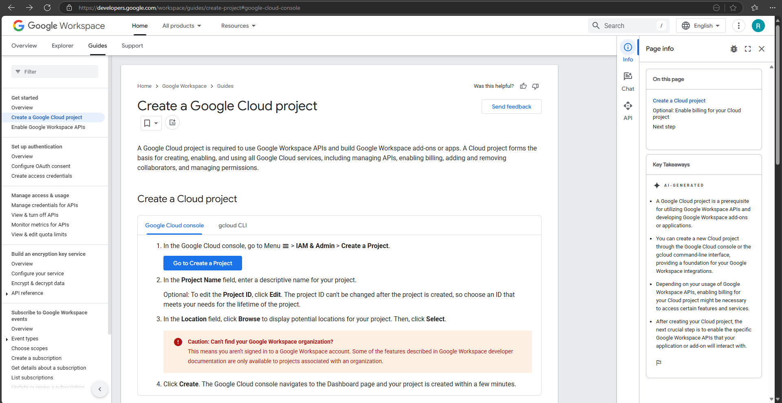

Click on **Go to Create a Project**

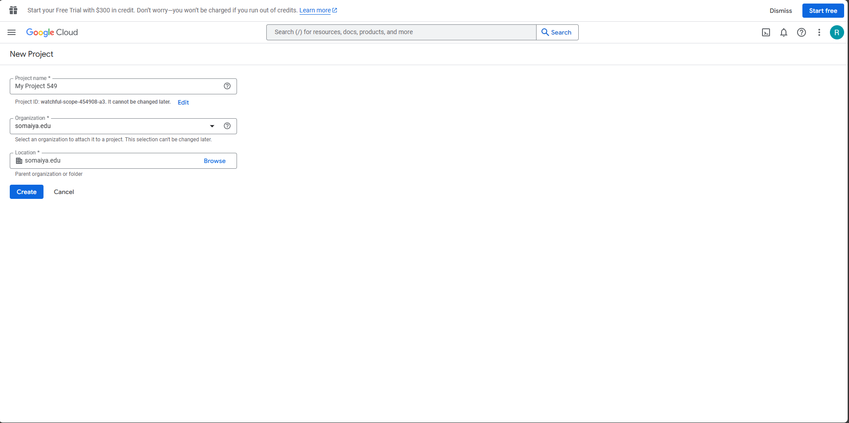

Give all the details and click on **Create**

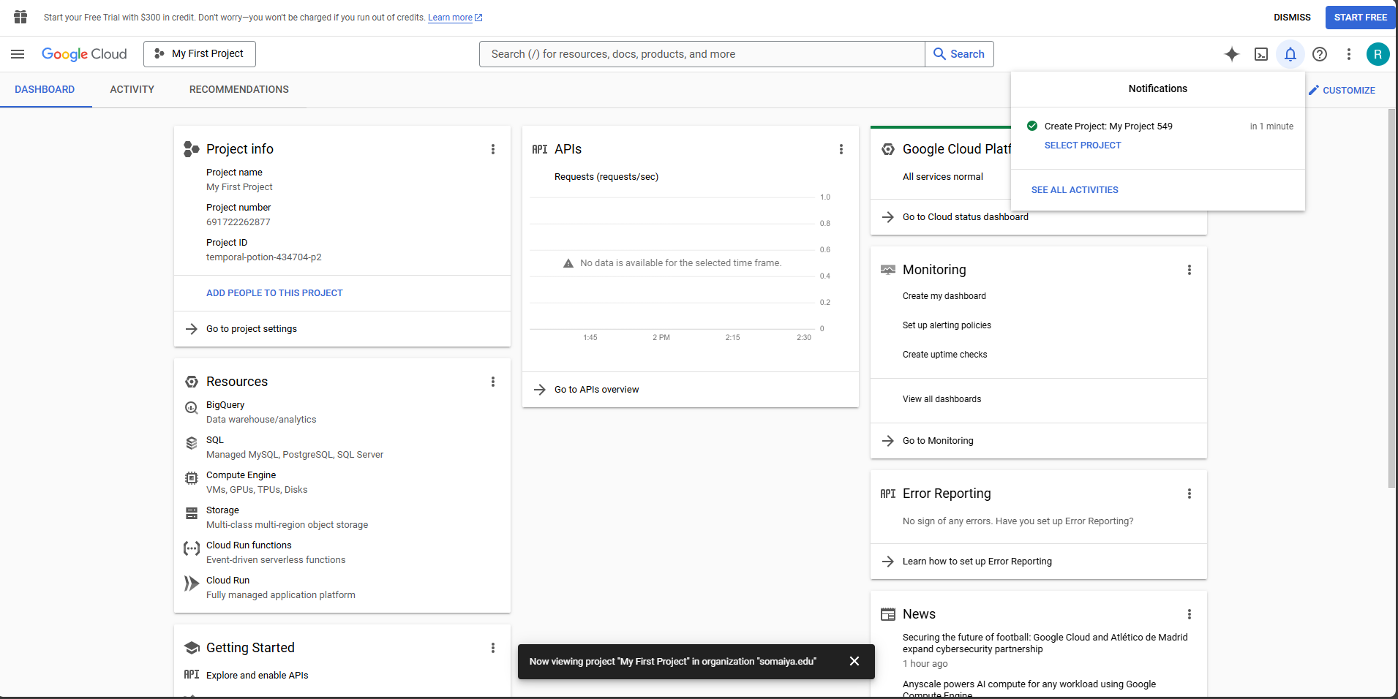

Your Project will be created

Now go to

<https://aistudio.google.com/apikey>

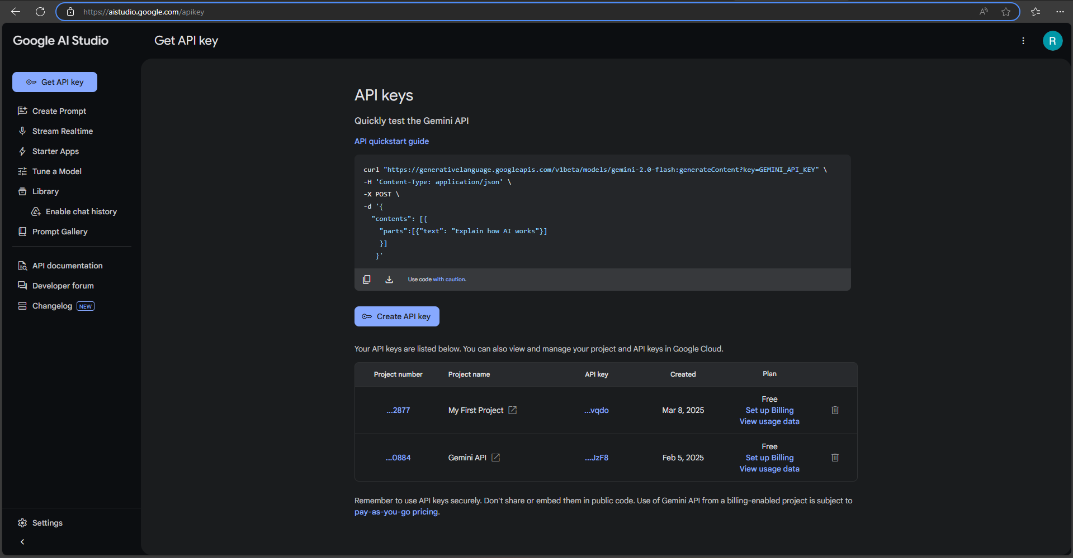

Click on **Create API key** and you'll see your project name. Click on it.

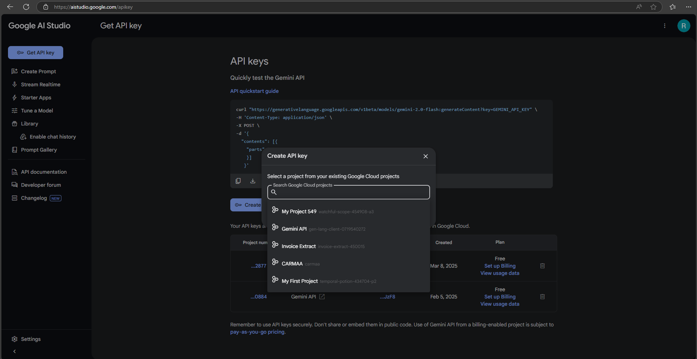

Click on **Create API key in existing project**

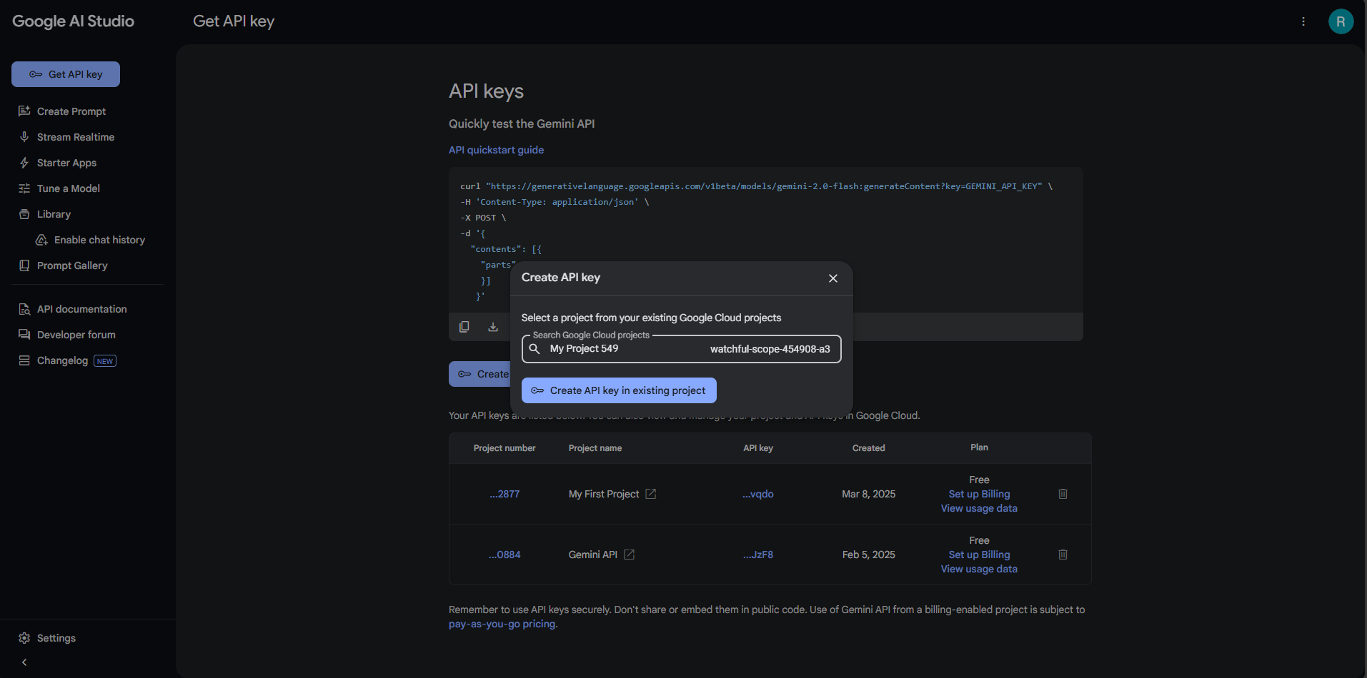

You’ll get API key. **Copy** and Save it somewhere safe.

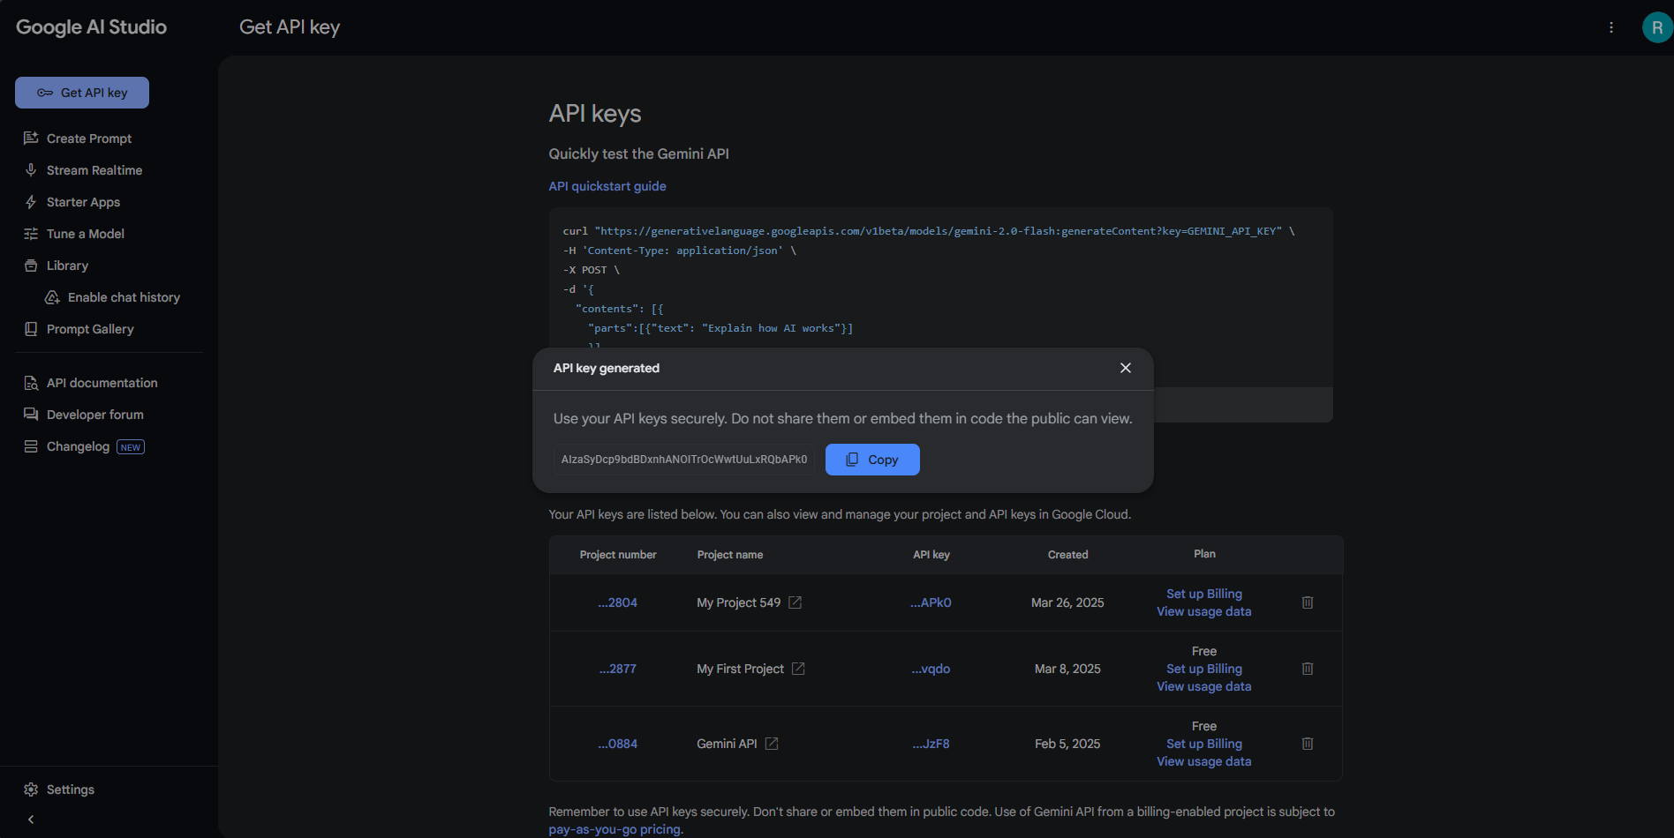

Now you can use the API key.

You can select the API model according to your convenience and you can check out the pricing on <https://ai.google.dev/gemini-api/docs/pricing>